5

Target Detection in Clutter

Often,detection oftargets is significantlydegradedby the presence ofclutter.The detectability of targets in clutter can be enhanced by exploiting the differential Doppler frequencies due to different velocities of the target and clutter.Chapter 1 discussed the use of delay line cancelers and Doppler flter banks.The efficacy of these techniques depends upon the spectral characteristics of the clutter.The spectrum of ground clutter is relatively narrow and centered at zero Doppler. Because delay line cancelers can be easily configured to have a null at zero Doppler,ground clutter is "easily"canceled using delay line cancelers.However, clutter due to reflections from sea,weather,birds,insects,and ground traffic,for example,do not have zero-mean Doppler.They are not well canceled by delay line cancelers.ADoppler flter bank often is a significantly better processor,

5.1 Introduction
Doppler filters can be implemented using either deterministic weights or adap- tive weights.This is similar to using deterministic or adaptive weights for an- tennas to aid in rejecting sidelobe jamming.In either case,the adaptive weight implementation is more expensive but the performance is often significantly improved.This chapter will analyze the relative and absolute performance at- tained by deterministic Doppler filters.A later chapter will analyze the relative and absolute performance attained by adaptive Doppler filters.These data can then be combined with cost data to select the preferred architecture.Note that cost data depend upon component availability.Thus,if adaptive processing is deemed too expensive in a particular application for a specified time period,this decision could change for the next implementation generation.

155
100

5.2.4 Carrier Frequency Sensitivity
The first portion of this chapter gives an overview of clutter characteristics and alternate methods of detecting targets in clutter environments.The next part discusses several aspects ofdelay line cancelers.These circuits are also called moving target indicators(MTI).Later chapters give a detailed analysis of the performance ofadaptive and nonadaptive Doppler filter bank implementations.
Under some circumstances,the ratio of the energy backscattered from the desired and undesired scatterers is a function of carrier frequency,and a choice of carrier frequency that maximizes the ratio,consistent with other system requirements, is made.Also,transmitting on several differentfrequencies and discriminating on the resulting observation vector can be used.

5.2 Clutter Discriminants

5.2.5 Azimuth Angle Sensitivity
When the clutter is a collection of point scatterers,the amplitude of the phasor sum is relatively sensitive to the azimuth angle to the radar.The amplitude return from a point target is relatively insensitive to this angle.Thus,comparing the amplitude of the received signal from two antennas,such as a monopulse antenna configuration,is usable as a discriminant technique.This technique can be coupled with that of the prior section for improved performance.
The detection capability of a radar system is limited by the phenomenon that often the reflections received by the radar comes from scatterers that are not of interest;this received radiation is termed a clutter return.The reflection received from a scatterer of interest is termed the target return.These two statements, while fairly trivial and obvious,are intended to emphasize that,to a large degree, the differences between clutter and target are largely in the mind of the observer. Thus,the procedures used to detect the presence of targets,while ignoring the presence of clutter,are based upon the exploitation of any known physical differences between these types of scatterers.Several differences between the scattering properties of targets and clutter exist and can be exploited.Examples of properties that may be useful are discussed in the following sections.

5.2.1 Target Elevation
Under some conditions,the scatter that is the target is above the level of the ground and the sources of clutter are at ground level.Techniques that discrimi- nate upon the basis of scatterer altitude are useful.There are,ofcourse,situations where this is not a useful discriminant.

5.2.2 Target Velocity
This is currently the most common technique used to discriminate between targets and clutter;it is useful when a significant velocity difference exists.

5.2.3 Transmission Polarization-Sensitivity
The energy backscattered from an object is a function of the polarization of the illuminating energy,and different objects usually have different polarization properties.This property may be exploited by transmitting a polarization for which the backscattered radiation at the receiving polarization from the unde- sired objects is relatively low.This technique has been used to reduce the weather clutter problem.Transmitting on several different polarizations and discriminat- ing on the resulting observation vector are theoretically conceivable.

5.2.6 Signal Bandwidth
If the undesired scatterer is essentially a homogeneous sheet of scatterers,so that the total undesired backscattered radiation is a linear function of the radar reso- lution cell,and simultaneously the desired target is essentaly a point scatterer, the ratio of desired received energy to undesired received energy increaseslin- early with increased signal bandwidth.Thus,using larger bandwidths is a clutter discriminant.
The choice of which of these discriminant techniques,or which combi- nation to use and an evaluation of the relative merits of the techniques clearly requires a knowledge of the backscattering properties of different types of re- fectors.The backscatering coeffcient varies enormously as a function of the specific class of cluter.The consistency of the coffcient is highest for weather, lowest for land;the sea return data is intermediate.This consistency seems to be intimately associated with the fact that there are only a few degrees of rain (possibly five between drizle and cloudburst),about twice this number of cases for sea variability,and vastly more cases for ground variability.As an example, clutter backscarter for ground return varies with clasifcations such as rural or urban or smooth asphalt road,rough asphal road,and wet snow on 1-in.grass. Some general statements can be made.One fairly consistent qualitative rule on backscatter properties,which coincides wich physical reasoning,is that smooch Surfaces backscatter less radiation than rough surfaces for angles sufficiently far from the vertical so that specular reflection is no longer significant.Thus,as an example,when specular return isnot signifcant,sea return will tend to increase
1

Surace

Increasing  Backscattered  Energy  HInocriinael Incidence Angle(φ)  Seivd | Rough Surtace  Ieidrile  Surface
Figure 5.1 Relative backscattering energy for smooth and rough surfaces.

as the sea state increases(a rougher surface)and as the carrier frequency increases (a rougher surface).In addition,the backscattered radiation for a rough surface is lessdependent upon incidence surface angle than that from a smooth surface. This latter condition is qualitatively indicated in Figure 5.1.

5.3 Parameter Definition for Ground and Sea Returns
This section is a qualitative discussion of methods of computing clutter cross section.It emphasizes that the dluter cross section varies over many orders of magnitude as a function of different parameters.An accurate computation of the clutter cross section is ifficult and treated in more detail by the sources cited in the bibliography.In addition,usually a radar design uses cluter parameter magnitudes specified by the intended customer.
The standard definition for the backscattered energy for a point target uses the parameter o,and the target cross section is assumedto be independent of the antenna beamwidths.The standard definition for the backscattered radiation from the Earth's surface assumes that the clutter cross section is a linear function of the illuminated area,and this implies an inherent assumption that the surface is homogeneous.Wich these assumptions and assuming the fat Earth geometry of Figure 5.2 and that the antenna illumination gain is constant within the

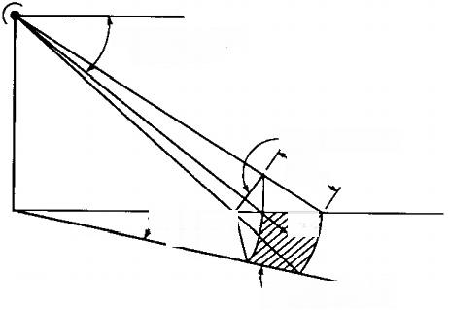  中=Depression Angle  (Grazing Angle)  △θ=Azimuth)  Beamwidth | Ai=Incidence Area  c 2  、

A =lumination Area
Figure 5.2 Surface echo area geometry.
illuminated region and zero gain outside the egion,the surface radar cross section,os,is
σs=σ⁰AL

where AL is the illuminated area and o⁰is the normalized surface cross section. An alternate definition is that

σs=γA;=ytanφ(Rct/2) σ⁰=γ sinφ
and some papers present results in terms of the normalized parametero⁰while others use the normalized parameter γ.An additional note¹of caution is that the symbology used is not consistent amongallinvestigators.That chosen for this chapter represents the majority opinion.
The major parameters usually considered to influence the magnitude of the scattering cross section are:

1.Type of terrain(e.g.,sea and ground);

1.Therelationship betwen A;and AL asumestha the surface resolutioncllisdetermined bythe signal bandwidch.This i the common condition for mainlobe cluter and corresponds to the condition that the grazing angle is not too close to the vertical.More precisely,tanø<2θrR/c, where θe is the elevation beamwidth.
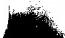

160 Radar Signal Processing and Adaptive Systems

3.Carrier frequency;
4.Transmitting polarization;
5.Receiving polarization;
6.Depression angle;
7.Homogeneity of surface.
These parameters are considered in the following sections.

5.3.1 Sea Return
The dependence of o degres versus incidence angleis of the general form in- dicated by the plot of Figure 5.3;the scale of the depression angl is intended to be logarithmic.The measured values of o degres range from about+10 dB at vertical incidence to as low as-70 dB at low grazing angles.The plateau region is bounded by the depression angles of 中e,the "critical angle,"and o degres. These angles are of the order of i degree and tens of degres (say,50 degrees), respectively,and their values are frequency and polarization dependent.For angles lesshan dp 。the log ofo degres is aproximately proportional to the log

0 dB

Backscatteng Parameter

10 Logσ0
Plateau Region
Near
Iiteie

-70 dB
中 Incidence Angle
中 90°
Figure 5.3 General dependence of o⁰on depression angle.

Target Detection in Clutter 161 of φ,as indicated in Figure 5.3,so
ø⁰=81φ”
This is also approximately true for the plateau region,so

σ⁰=82Φᵐ2
The trends as indicated by the values of nl,n2,and the value of中care important. The following conditions are typical:
5.3.1.1 As the Sea State Increases
1.o⁰increases for all depression angles.
2.The value ofφedecreases with increased sea state and typical values are
5 degrees for the calmest sea and 1 degree for the roughest sea.
3.The values of nl and n2 remain constant at approximate values of3.0 and 0.6,respectively,so denoting the value of o degrees at the critical angleφc as oe for angles less thanφc

σ⁰(φ)=σc(φ/Φe)³

and for the plateau region

σ⁰(φ)=σe(φ/Φ)⁰.6
5.3.1.2 As the Carrier Frequency Increases
1.σ degrees increases as approximately the third or fourth power for calm seas and approximately as the Oth or first power for rough seas.
2.The value of φe decreases with frequency.
3.The values of nl and n2 are independent of frequency.

It should be noted that statements 2 and 3 for the sea-state variation and the frequency variation are identical in form and corroborate the previously stated dependence of ocon surface roughness.
5.3.1.3 Polarization Dependence
The dependence of sea backscatter upon polarization will be summarized by con- sidering the values ofo⁰(VV)transmitting and receiving vertical polarization; σ⁰(HH)transmitting and receiving horizontal polarizations;and σ⁰(VH),

which is the cross-polarization component,and for a reciprocal transmission medium this is equal to o₀(HV).
The ratio ofo⁰(VV)/σ°(HH)is essentially independent of the depress ion angle but is a function of carier frequency and sea state.The general func- tional relationship is that for smooth surfaces(calm seas and the lower portion of the microwave band),the ratio ofo⁰(VV)/o⁰(HH)isquite large and is of the order of20 dB to 30 dB.As the surface roughness increases,the ratio approaches 0dBand sometimes is a few decibels negative.Information concerning the cross- polarization backscattering cross sections is quite meager.
Another parameter that affects the sea backscatter is the wind,both with respect to speed and relative direction.The relative direction is significant because ofthe differences between the value of o⁰forupwind,downwind,and crosswind. These differences are of the order of 5 dB,and the relative ordering is
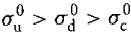
(vertical polarization)
(vertical polarization)

where the subscripts u,d,and c refer to upwind,downwind,and crosswind, respectivel.In addition to the directional effect,the magnitude of o⁰is stated to be a function of wind velocity such that oo in decibels is a linear funcion of the logarithm of the wind speed.

5.3.2 Ground Clutter
The general trends concerning the variation of the magnitude of the clutter return for each particular class of ground scatter seem to have the same form of functional variation as does the energy backscattered from the sea.That is,the form of the variation is dependent upon surface roughnessand the operating frequency.The backscattering coefficients tend to follow the functional variation given by Figure 5.1.

5.3.3 Weather Return
That the magnitude of the clutter return from precipitation is predictable to a high degree of accuracy is clear from the fact that radar data are often used by meteorologists for determining the precipitation rates and general weather char- acteristics.
The total magnitude of the clutter return is dependent upon the volume of precipitation intercepted by the beam and by the backscatter characteristics of the particular type of precipitation.Thus,for azimuth and elevation antenna

beamwidths of θA and θe steradians,respectively,and a range resolution ofδR, the volume,V,intercepted at range R,assuming the clutter fills the volume,is given by

V=θAθER²8R=4π R²8R/G

where Gis the antenna gain.Under the assumption that the individual scatterers are spherical and small compared to the wavelength,the scattering cross section per unit volume may be theoretically derived as
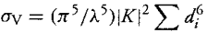
where d;is the diameter of the ith drop and the summation is over all of the drops in the volume.The constant K has been determined empirically and is stated to be equal to 0.93 for rain and equal to 0.2 for ice crystals and snow.The variation of ov as the inverse fourth power of frequency occurs because of the assumed validity of the Rayleigh approximation for the scattering from spheres that are much smaller than the wavelength.This approximation begins to lose validity for wavelengths smaller than 3 cm.The summation can be related to rainfall rate as
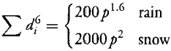
where p is the precipitation rate in mm/hr(the equivalent after melting,for snow).A convenient plot of these relations is shown in Figure 5.4.
In addition to the standard Doppler techniques used forclutter return rejec- tion,rejection of weather clutter is sometimes implemented using polarization- sensitive techniques.The classical implementation has been to transmit and receive on one of the circular polarizations.It can be shown that if a scatterer is a sphere,the polarization of the scattered energy is orthogonal to the polarization of the transmit/receive antenna and,therefore,the system will not detect the presence of spherical targets such as raindrops.Since the polarization scattering properties of targets are dependent upon shape,other scatterers,such as aircraft, will return an electromagnetic wave of a polarization that is not orthogonal to the receive antenna and the SCR will be increased by this technique.In addition, polarization-sensitive techniques are implemented at RF so that it and Doppler techniques are compatible and the combination of the techniques may be used to produce larger SCRs that either could produce alone.
There are two limitations in the degree of cancellation achievable by the polarization cancellation technique.One limitation is that raindrops are not

Radar Signal Procesing and Adaptive Systems
164

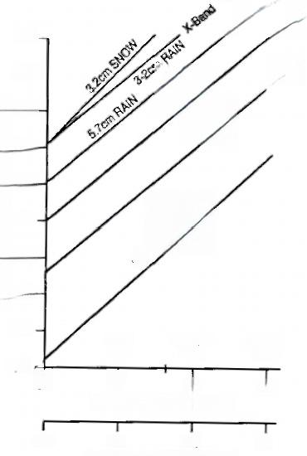
(cn²/m³nit volume
Echoing Area PerUnos,
-C-Band S-Band
10²-
10³
10cm RAIN
10⁴
23cm RAIN
10⁵-
10⁶
10⁷
108
109

10-1⁰
Medium Rain
10-11
10
Rate,mmHour

1.0
Mixing Ratio (Curve a),gm/m³
1.0
Precipitation
Heavy Rain
Lig
Rain
3.2cm CLOUD
1.Band
0.01
100
0.1
0.1
10

Figure 5.4 Echoing area of precipitation and cloud.

precisely spherical,and this degrades the performance of a system that is opti- mized for spherical shapes.This limitation becomes more severe during heavy intensity rain(when the clutter cross section is largest)since the departure from spherical shapes apparently increases with drop size.The second limitation is caused by the difficulry of designing an antenna with a constant polarization over the full beamwidth.

5.4 Doppler Filtering Techniques
Doppler processing improves the detection of targets in clutter by exploiting the Doppler frequency difference between a target and cluter.This is done by transmitting and coherently processing a sequence of Npulses.The period between pulse transmisions is usually constant,denoted as T,and termed the pulse repeitioninterval.The processor is of the form indicated in Figure 1.16.At any time instant,the output ofeach delay segmentis the voltage corresponding to the recurn from the same range cell for a particular transmitted pulse.That is,the

Target Detection in Clutter 165

tapped delay line is simply a mechanism to obtain time alignment of the returns due to rhe different transmitted pulses.This block diagram is appropriate either foran MTI circuit or fora Doppler filter.The difference between the two circuits is the design rationale used to choose the values of the weights.The weights are chosen so as to produce a particular gain versus Doppler frequency characteristic. The design criterion for an MTI circuit is that the gain characteristic has a null at a specified Doppler frequency.This frequency is usually zero but can be any otherfrequency.For the Doppler flter there are two design criteria.One is that the circuit has a large response at the target's Doppler;the other is that the response far from the target is small.

5.4.1 MTI Delay Line Cancelers
The single delay element canceler is shown at the top of Figure 5.5 and is a duplication of Figure 1.14.It is a single delay canceler(or two-pulse canceler). The technique can be generalized to a multiple delay element canceler and a three-pulse canceler is discussed later.

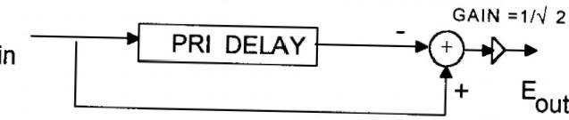
E

(a)

Pulse 2 Return

Pulse 1
Return
(b)MTI Phasor Diagram

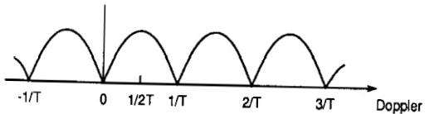
(c)Doppler Response Curve
Figure 5.5 MTI delay-line cancellation

The MTI canceler shown at the top of Figure 5.5 is ideally implemented at RFand performs the operation that
eou(t)=[ein(t)—ein(t-T)]/√2

To ensure that the output voltage equals zero for a zero Doppler reflector,it is mandatory that the delay exactly equals the pulse repetition interval.The implementation of this delay is essentially impossible at RE.
This impossibility can be seen by noting that a cable’s propagation velocity is approximately equal to the velocity of light so that the time delay induced by propagation through 3m of cable equals 0.01 μs.For the typical search radar PRF of 300 Hz,the PRI equals 3300 μs,so the cable length required to generate the required delay is approximately 1000km.Thus,the circuit cannot be directly implemented.A later section discusses practical methods ofobtaining the required delay
There are several complementary methods of analyzing the improvement of target detection in clutter obtained using Doppler processors.A convenient method for MTI delay line cancelers is via the phasor diagram depicted at the lower left portion of Figure 5.5.An algebraic technique is also used later.
The voltage return from a specified range cell due to the transmission of pulse 1 is shown as the horizontal line of the phasor diagram.The phase of this return is depicted as zero without loss ofgenerality since only the phasedifference between pulse returns is important.The phase of the return for pulse 2 is denoted as φ.The phase difference is due to the range change of the target during the time between pulse transmissions.Thus,for a carrier frequency of fo,a reflector velocity of v,and a velocity of propagation of c,
φ=2π fovT/(c/2)=2π foT fo=fov/(c/2) (5.1)

where fo is the target Doppler frequency.Note that at zero target velocity the phase equals zero.Thus,when the two successive pulses are subtracted,as in a delay line canceler,the output voltage equals zero.Similarly,the output equals zero when the phase difference equals 2π or any integer multiple of 2π.These nullconditions are termed blind speeds.The Doppler frequencies corresponding to the null speeds are obtained by noting from the previous equation that the phase shift is integer multiples of 2π when the reflector's Doppler frequency is integer multiples of1/T.Also note that since the PRF equals the reciprocal of the pulse repetition period,the blind Doppler frequencies occur at integer multiples of the pulse repetition frequency.The circuit gain to any Doppler frequency is indicated by the transfer function magnitude shown by the lower right-hand portion of Figure 5.5.The maxima of the transfer function corresponds to reflector velocities termed “optimum”speeds.These correspond to the condition

that the phase shift between pulse returns equals odd multiples of π.For this condition the subtraction of the two returns is equivalent to adding the phasor magnitudes.
The target response at other target Dopplers can be obtained from the filter transfer function,H(f).The transfer function can be computed from the phasor diagram of Figure 5.5.The output voltage,eout,equals [1-exp(-jφ)]/√2 and therefore
eout =[1-exp(-j2πfDT)]/√2 leouel=|H(f)=√2|sin(πfDT)
(5.2)
The performance of the circuit is the combination of the response to the target and the response to the clutter.The response to target as a function of the target's Doppler frequency is given by(5.2)or the sketch of Figure 5.5.The response to clutter is more complicated since ground clutter,such as trees,is wind blown,causing the pulse-to-pulse phase changes to be approximately random.If a reflector is completely stationary,the reflected waveform is at zero Doppler.The motion of the reflector causes the refected waveform to have nonzero Doppler. Clutter reflectors usually consist of many small reflectors,and each reflector has a
different Doppler.A typical example is that the wind causes the leaves and limbs of trees to have different motions.Since the ground clutter is tethered to the ground,its average velocity and therefore the average Doppler are zero.However, the combination of the differing motions is that the reflected waveform has a spectral spread about zero Doppler.The spectral spread depends upon the type of clutter and the wind conditions.Examples of the velocity spread are given by the data of Table 5.1.

5.4.2 Clutter Spectral Density
The circuit's effect upon clutter can be analyzed using the clutter power density
spectrum.The definition of a power density spectrum,C(f),is that the differ-
ential power at the particular frequency,fi over the bandwidth,df is evaluated
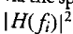,so for any circuit the total output clutter power,pco can be calculated
via the spectral power density as C(fi)df.The power gain of a filter at fi equals
as
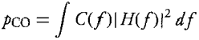
(5.3)

where the integration limits are-∞to+∞ .
The spectral spread of the clutter is obtained by combining the entries of Table 5.1 wich the carrier frequency using(5.1).Thus,the standard deviation

Table 5.1
Clutter Velocity Speed

Source of clutter Wind speed (knots)o,m/s
Sparse woods..  Wooded hills...  Wooded hils...  Wooded hills...  Wooded hills...  Sea echo……  Sea echo.….  Sea echo ..  Sea echo......  Chaff…………  Chaff………  Chaff………  Rain clouds.... | Calm  10  20  25  40  … …  … ……  8-20  Windy  25  ……… …  ……… … | 0.017 0.04  0.22  0.12  0.32  0.7  0.75-1.0 0.46-1.1  0.89  0.37-0.91 1.2  1.1  1.8-4.0

of the clutter spectrum is
0f=αvf./(c/2) (5.4)
The clutter spectrum is approximately Gaussian shaped and is given by
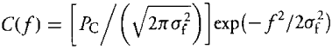
(5.5)

Figure 5.6 illustrates a typical ground clutter spectrum and the magnitude
squared of the filter transfer function.The horizontal axis is the ratio of the

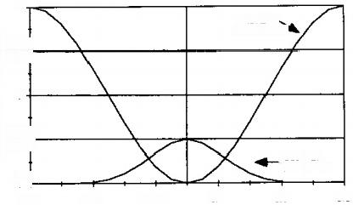
POWER GAIN-NUMERIC
2
FILTER、
RESPONSE
1.5+
1

0.5—
0+ -0.5
CLUTTER sPECTRUM
-0.3 -0.1 0.1 0.3 0.5
NORMALZED DOPPLER FREQUENCY
Figure 5.6 Clutter spectrum and two pulse canceler power response.

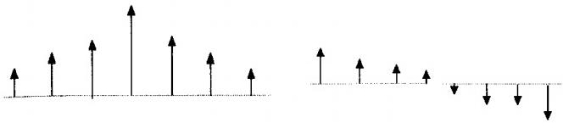
Figure 5.7 Antenna scanning induced clutter spectrum.

Doppler frequency to the PRE.As indicated by(5.3),the output clutter power is given by the integral of the product of the two sketched functions.It can be seen that the nullof the power transfer function is at the Doppler frequency of the peak of the clutter spectrum so that the output clutter power is much less than the input clutter power.
Another major contributor to the clutter spectral spread is the scanning of the radar.Specifically,note that the derivation of (5.2)assumed that the magnitude of the returns of the two pulses are equal.This is correct for a step scan radar but is not correct for a mechanically scanning radar.Thus,consider an isolated stationary point reflector.Scanning causes the antenna gain in the direction of the reflector to vary from pulse to pulse.As depicted by the left-hand sketch of Figure 5.7,the voltage of the return varies from pulse to pulse due to the antenna gain variation.The right-hand sketch depicts the voltage output from the two-pulse canceler.Since the output is not zero,this is equivalent to the output being caused by clutter spectral spread.An equivalent clutter spectral width for this effect is given by
Cf=0.265(PRF)/N (5.6)
where N is the number of pulses during the dwell.Note that though the suc- cessive input pulses have the same phase,they have different amplitudes and the output voltage is not zero.Thus,the canceler is sensitive to both amplitude and phase,and variations of pulse amplitude due to transmitter pulse-to-pulse amplitude variation will also cause nonzero output.
The total spectral width due to multiple effects is obtained by combining them in an rms manner so that,as an example,the total width for two effects is
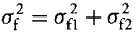
(5.7)

5.4.3 Clutter Attenuation and Improvement Factor
The earliest method used to evaluate the performance of a Doppler flter is via the ratio of the input clutter power to the output clutter power.Thus,the clutter

attenuation,CA,is defined as
CA=Pc/Pco (5.8)
This performance measure is sometimes poor since it is independent of the filter's gain at the target Doppler frequency.Abetter measure is the Doppler frequency- dependent improvement factor,I(fo),defined as the ratio of the output SCR, (SCR)out,to the input SCR,(SCR)in.Thus,
I(fb)=(SCR)ouc/(SCR)in (5.9)

For a linear receiver,superposition prevails and(5.9)can be rearranged as
I(fo)=(S₀/S)/(Pco/Pc)=(S₀/S)CA (5.9a)

so the improvement factor evaluates to the gain to target(signal)multiplied by the clutter attenuation of (5.8).
The signal gain depends upon the Doppler frequency of the target.For many radars,the target Doppler frequency is highly ambiguous,so it can be modeled as a random variable that is uniformly distributed over the PRF and the signal gain can be defined as the average signal gain.Note that the Doppler frequency of thermal noise is also uniformly distributed over the PRE.Thus,the average signal gain equals the power gain of the noise.Since the circuit's weights are selected for unity noise gain,the average signal gain also equals unity and the average improvement factor,I,equals the clutter attenuation
I=CA (5.9b)

However,note that this equivalence is only correct for a linear receiver.For a nonlinear receiver it is important to evaluate the performance via the improve- ment factor defined as(5.9)because the clutter attenuation definition will give misleading results.
For the two-pulse canceler,|H(f|is given by(5.2)and it can be used in (5.3)to evaluate the circuit's performance.Ar alternate computational proce- dure,which is often simpler to solve,evaluates the output clutter power using the impulse response of the MTI filter rather than the transfer function.This technique is based on computing the output power via Parsavells theorem.One form of the Parsavel's theorem states that the following integrals are equal
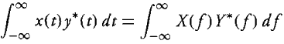
(5.10)

where x(t)and y(t)have Fourier transforms X(f)and Y(f),respectively.The applicability of this result is that the Fourier transform of the clutter spectrum equals the autocorrelation function of the clutter,denoted as Rc(t).The Fourier transform of the magnitude squared of the transfer function equals the filter's autocorrelation function R(t).Thus,
(5.11)

The clutter autocorrelation function for the Gaussian spectrum of(5.5)is
Rc(z)=exp{-2(πot)²] (5.12)

This theorem of(5.11)is especially useful for delay line circuits because the filter's autocorrelation function is in terms of delta functions.Then the resulting inte- grals are in terms of delta functions,and these are simple to evaluate.The applica- ble integral relationship for a delta functionδ(t)and an arbitrary function a(t)is

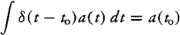
and the limits for this and the following integrals are from-x to +∞ .
The impulse response for the single delay element canceler,b(t),and its autocorrelation function Rh(t)are
h(t)=[8(t)—8(t-T)]/√2 Rh(t)=fh(t)b*(t-t)dt
(5.13)
The evaluation of Rh(t)is easily done graphically in a manner similar to that used to obtain the output of a matched flter to a biphase code.Thus,the top left part of Figure 5.8 depicts the filter impulse response;the bottom left part depicts an undelayed version of the impulse response.Multiplication and
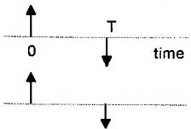
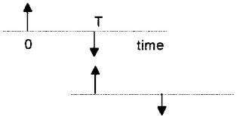
Figure 5.8 Computing impulse response of a two pulse canceler

summation of the two sketches yield the value of Rh(0).Since each impulse has strength 1/√2,the value of Ra(0)equals unity.The right-hand side of the sketch evaluates Rh(T).The top right part of the figure again depicts the filter impulse response;the lower right depicts the impulse response delayed by T. Multiplication and summation yield the result that Rh(T)equals one-half.As
the autocorrelation function is even,Rh(-T)also equals one-half so that
Rh(T)=[28(t)-δ(t-T)-δ(t+T)]/2 (5.14)

Then applying Parsavells theorem with the integral relation for delta functions and denoting the clutter's autocorrelation function as Rc(t)gives the output clutter power as
pco=[2Rc(0)-Rc(T)-Rc(-T)]/2 (5.15)

A special case,usually applicable for ground clutter,is that the clutter spectrum is even and centered at zero.Then the autocorrelation function is even,so

PCo=Rc(0)-Rc(T) (5.16)

From(5.9),the improvement factor is
I=Rc(0)/[Rc(0)-Rc(T)] (5.17)

and the Gaussian autocorrelation function is given by(5.12).An approxima- tion,valid for the important case of high cancellations is obtained via a series approximation of(5.12).Since for smallx,exp(-x)≈1-x,the improvement factor for a Gaussian spectrum is approximately
I≈1/[2(πofT)²]=(PRF/σ)²/19.75 (5.18)

Figure 5.9 is similar to Figure 5.6 except it shows the power transfer function for two different PRFs.It can be seen that as the PRF increases,the level of the power transfer function decreases and this aides in explaining the increase of the improvement factor with PRF computed using(5.18).The figure illustrates the trends of behavior:the improvement factor increases with PRF since the notch width increases;it decreases with increased clutter spectral spread since the clutter spreads out of the notch.
A typical example of the improvement factor computed using(5.18)is for a radar carrier frequency of3GHz,a PRF of 1kHz,a 10-pulse dwell,and clutter

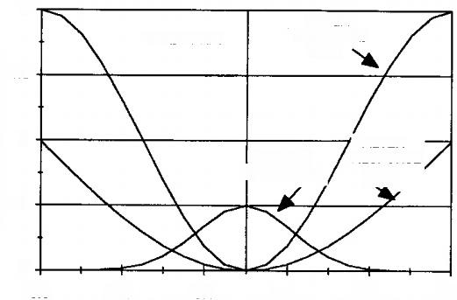
POWER GAIN-NUMERIC
2
PRF2>PRF1
1.5

1
RESPONSE
PRF2
0.5

0
-0.3 -0.1
0.1 0.3 0.5
FILTE尺
RESPONSE
PRF1
CLUTTER SPECTRUM
FLTER
-0.5
NORMALIZED DOPPLER FREQUENCY
Figure 5.9 Two pulse canceler power response for different PRFs.

such that ovequals 1 m/s.Then on equals 20 Hz,of₂equals 26.5 Hz,and the total spectral spread equals 33.2 Hz,so the improvement factor equals 16.6dB. Often this is an inadequate improvement factor and improved MTI circuitry is required.

5.4.4 Three-Pulse Cancelers
Improved MTI cancellation can be obtained using multiple delay element con- fgurations.An example is the two-delay element canceler shown in Figure 5.10. It is a three-pulse canceler and can be viewed as a cascade of two-pulse cancelers. The concept is that the cascading should improve the rejection of the clutter. Each single delay line filter has a weight of w in the direct path and-w in the delay path.The sum of these weights equals zero,and therefore each filter has a null at zero Doppler.The impulse response of the circuit can be evaluated from the figure by inspection.The direct path from input to output has a gain of w²;there are two paths with a single delay for a total gain of-2w²;there is a single path wich a double delay,so its gain equals w².Thus,the relative weights are 1,-2,1.An alternate block diagram for this delay line canceler is shown in Figure 5.10(a).The impulse response when the weights are normalized to unit thermal noise gain is

b(t)=[8(t)-28(t-T)+8(t-2T)]/√6 (5.19)

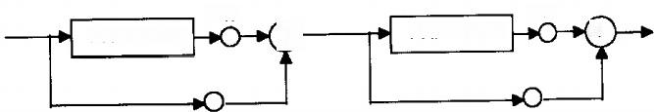
-W
-W PRI DELAY
X
PRI DELAY +

W W
Figure 5.10a Conceptual block diagram of three pulse canceler.

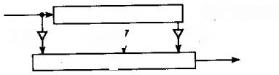
Tap Spacing=T 1/6
-2N6 ∑
Delay Line
1/NB
Three Pulse Canceler Block Diagram Figure 5.10b Alternate block diagram of three pulse canceler.
Using an analytic procedure that is identical to that used for the single delay
line canceler,it can be shown that the improvement factor is given by
I=Rc(0)/[Rc(0)-(4/3)Rc(T)+(1/3)Rc(2T)]} (5.20)

Using the same series approximation used previously,this evaluates to
I≈(PRF/σf)⁴/780 (5.21)

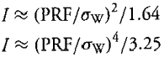
For the example previously used,the improvement factor evaluatces to 32.0 dB versus the previous 16.6 dB.Equations(5.18)and(5.21)are clutter spectrum dependent.Thus,for a rectangular spectrum of total spectral widch,ow,the comparable equations are
(5.18a)
(5.21a)

The improvement factor increases as the order of the delay line canceler increases.As an example,if the clutter spread is only due to the radar scanning,so that the spread is given by(5.6)and the specrum is approximated as Gaussian, the improvement factors for a two-pulse,single delay line canceler I,a three- pulse,two delay line canceler I₂,and a four-pulse,three delay line canceler I₃ are,respectively,
I₁=N²/1.38 I₂=N⁴/3.85 I₃=N⁶/16.0 (5.22)

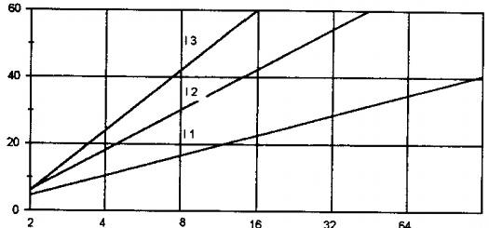
MPROVEMENTFACTOR(dB)
32 128
PULSES PER DWELL
Figure 5.11 Improvement factors for delay line cancelers.

Figure 5.11 graphs these equations.The graphs demonstrate that the improve- ment factor increases when a higher order delay line canceler is implemented. However,the increased improvement factor has an associated cost.This is indi- cated by the two-and three-pulse canceler response curves of Figure 5.12.The weights for both cancelers are normalized,so the average signal gain for both filters equals unity.From(5.13)and(5.19),respectively,the maximum voltage gain of the two-and three-pulse cancelers are 2/(√2)and4/(√6),respectively. The power signal gain for the cancelers is given by
|H₁(fI²=2[sin(π foT)]² |H₂(f)I²=(8/3)[sin(π foT)]⁵(5.23)

The peak power gain of the two-pulse canceler equals two;for the three- pulse canceler the peak gain equals 8/3.Note that the derivation ofthe maximum

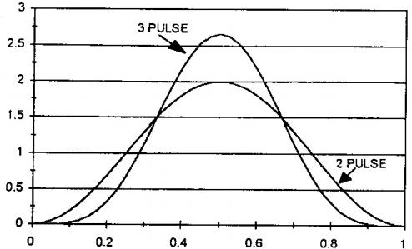
SIGNAL POWER GAIN(NUMERIC)
NORMALIZED DOPPLER FREQUENCY
Figure 5.12 Signal gain of two and three pulse cancelers.

176 Radar Signal Processing and Adaptive Systems

detection range equations assumed that the signal gain for an N-pulse transmis- sion equals N.For the two-pulse canceler this gain is achieved only for an optimum speed target.For the three-pulse canceler this gain is never achieved. Also note that for the two-pulse canceler,the power gain is less than unity for 50%of the Doppler frequency range;for the three-pulse canceler the gain is less than unity for 57%of the Doppler range.This demonstrates that for large portions of the Doppler range,the signal gain is less than that achieved by a single pulse processed without a delay line canceler and that the decreased gain problem increases as the order of the MTI filter increases.It can be shown that the decreased signal gain problem with increased order of MTI filter is true in general.

5.4.5 Generalized Canceler Weights
The transfer function of the previously considered two-pulse,single delay line canceler is of the form
H₁(f)=g1[1-exp(-j2π foT)]
andgi is chosen to achieve unity noise power gain.That of the three-pulse,two delay line canceler is of the form
H₂(f)=g2[1-exp(-j2π foT)]²

In general,for an M-delay canceler,the transfer function is of the form
HM(f)=gM[1-exp(-j2π foT)]M (5.24)

and using the binomial expansion
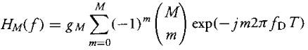
where(M)denotes the binomial coefficient.Thus,the weights are proportional to the binomial coefficients.Examples include
M=1→(1,-1)
M=2→(1,-2,1)
M=3→(1,-3,3,1)
M=4→(1,-4,6,-4,1)

Target Detection in Clutter 177

Note that for all cases the sum of the weights equals zero.This is necessary to ensure a null at zero Doppler.In addition,from(5.24)the derivative with respect to Doppler frequency equals
(d/dfo)[HM(f)]=MgM[1-exp(-j2π foT)](M-1) (5.25)

so for M greater than or equal to 2,the derivative at zero Doppler equals zero. In general,binomial weights cause a 2Mth zero for|HM(f)I²at zero Doppler.

5.4.6 Delay Line Canceler Shortcomings
Though the delay line cancelers discussed in the previous sections can improve the detectability of targets in clutter,there are problem areas.Examples of prob- lems are indicated in Figure 5.13.This shows the transfer function of a delay line canceler with two desired targets at blind speeds and volume clutter,which has a nonzero center Doppler frequency due to wind effects.As a numeric ex- ample,a system with a 1-kHz PRF has blind speeds at 0,1 kHz,and 2kHz,for example.The transfer function has maxima at 0.5kHz,1.5 kHz,and 2.5 kHz, for example.Assume a 2-GHz carrier frequency,a 728-knot target,and chaff at a10-km altitude.For standard models of wind velocity change with altitude,the mean Doppler frequency of the chaff equals 533 Hz,very close to one of the fil- ter's maximum response frequencies.The Doppler frequency of the target equals 5kHz,and this equals a blind speed.In addition,there is a large detection loss for detection oflow-speed targets.As an example,for a72.8-knot radial velocity

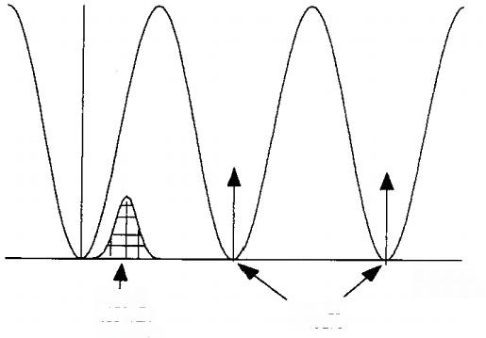
DOPPLER
FREQUENCY
DESIRED TARGETS
VOLUME
CLUTTER
SPECTRUM
Figure 5.13 Canceler response problems

target,the Doppler frequency equals 500Hzand this is an optimum speed.Note that this radial velocity will occur when a high-speed target(say Mach 1 or 2)is close to a crossing trajectory.For a three-pulse canceler the power gain for this target equals(8/3)².However,for a 10-knot radial velocity target,the Doppler frequency equals 69Hz and the gain for this target is 26.7 dB less than that for the72.8-knot target.Thus,it is difficult to detect low Doppler frequency targets.
The blind speed problem can be alleviated using stagger coding.The poor detectability of low-speed targets can be alleviated using Doppler filter banks.

5.4.7 Stagger-Coded MTI Waveforms
The blind speeds of an MTI processor are due to the use of a periodic transmit waveform.A method of partially alleviating the blind speed problems of delay line cancelers is to use an aperiodic waveform.One example of an aperiodic waveform is the staggered PRF waveform depicted in Figure 5.14.It can be seen that the waveforms period alternates between two values.The values can be expressed as
Ti=T(1+ε) T2=T(1-ε) T=(Ti+T₂)/2 (5.26)

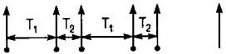
T₁=T(1+e);T₂=T(1-e);T=(T₁+T₂/2
(a)Stagger Coded Waveform

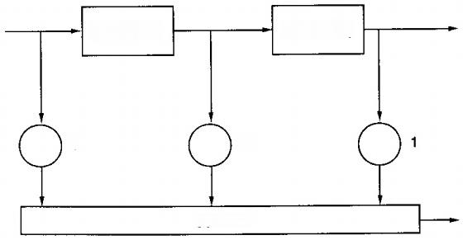
Delay=T₂
Delay =T₁

1 -2

Summer
(b)
Figure 5.14 Three pulse stagger code and Doppler filter.

The waveform is processed by a two-delay element circuit,and the delays of the two segments differ to match the diferent pulse periods.When processing pulses with the relative spacing of che left three pulses ofthe figure,the circuir's impulse response,for weights normalized to unity noise power gain,is
h₁(t)=[8(t-Ti-T)-28(t-Ti)+8(t)]/√6 (5.27)
For the other period order,the circuit's impulse response is h2(t)=[8(t-T-T)-28(t-T)+δ(t)]/√6
For either case,the power transfer function equals

IH(f)I²=[6+2cos(5πfT)-8cos(2πfT)cos(2πfTe)]/6 (5.28)

The circuit sill has a nullat zero frequency.However,the blind speed problem has been reduced because it does not necesarily have nulls at integer muliples of the pulse repetiton frequency.An example of the Doppler response obtained using stagger code is shown by the curves of Figure 5.15.The upper left-hand response is for the case of e=0.1.Note that the response is periodic at the Doppler frequency equal to 1/eT.For comparison,the upper right-hand re- sponse is the no stagger case.The lower curves are for an expanded scale and thethree values for the stagger coeffcient of 0.0(no stagger),0.1,and 0.3.It can be seen that the response to low-speed targets increases as the coefficient increases.However,as shown later,this increased response causes a degradation of the ability to reject clutter.
Evaluation of the derivatives at zero Doppler gives a partial explanation of cheincreased gain in the vicinity of zero Doppler for stagger coding.From (5.25)there is a fourth-degree null at zero Doppler for a nonstaggered chree- pulse canceler and a second-degre null for a two-pulse canceler.Using the frst two terms ofa Taylor series expansion for(5.28)shows that the value of|H(f)I² in the vicinity of zero is
|H(0+)I²=16(πefT)²
and for nonzero ε the derivatives are like that of a two-pulse canceler rather than a three-pulse canceler.
There is a trade-off in the choice of e since at the first blind speed,the Power gain is not equal to zero but equals
H(1/T)²=5[2-2cos(2πε)]≈5(2πe)² (5.29)

180 Radar Signal Processing and Adaptive Systems

E=0.1 3=0. | 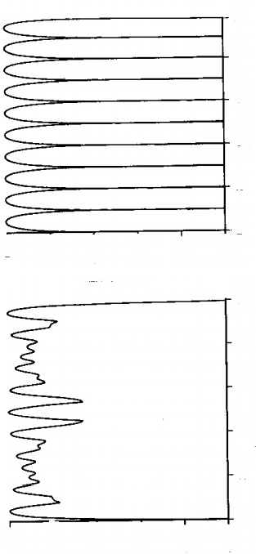  6 00 8 100.00  0.00-  00.0  +10.00 -10.00  -20.00 -20.00-  -30.00  000-  2.00  001 000  Normalized Doppler  Normalized Doppler  000  . 0 0 十  5 0  2 00 4 006.00  品 0 0 . 0  00'09-  0 0 . 0 4  (ap)eprqubew  (ap)epruuBew  -30.00- | Figure 5.15 Response curve for stagger coded waveform.

Target Detection in Clutter 181

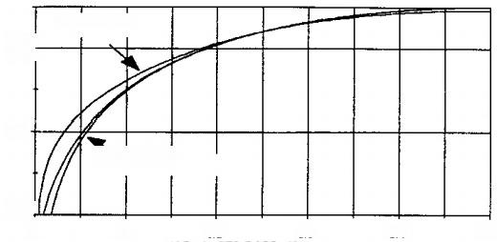
NORMALIZED MAGNITUDE (dB)
0.3 STAGGER
-10

-30
NOSTAGGER

-50↓
0 0.1 0.2 0.3 0.4 0.5
NORMALIZED DOPPLER
(c)
Figure 5.15 (Continued)

The peak response is approximately at the Doppler frequency equal to 1/2T and the peak value is approximately equal to 16.Thus,the ratio of the gain at the first blind speed to the peak is approximately equal to(πε)²,so large values ofe are desirable to maintain large gain at this frequency.However,the response is periodic at the frequency when both cos(2π fT)and cos(2π fTe)equal+1 or-1.This occurs at a Doppler frequency of 1/eT.Since it is desirable that the periodic frequency be large,small values of ε are desired.Therefore,there is a tradeoff between having a large gain at the nominal first null,having the response periodicity cover a large frequency range and,as discussed in the next section,a large improvement factor.
Pulse stagger can be used for an arbitrary number of pulses.As shown previously,a three-pulse stagger is a complicated tradeoff.Designs using an increased number of pulses are an even more complicated tradeoff.In addition, no methodical design method is known and trial-and-error design is necessary.
Another potential problem with PRF stagger is that second-time-around clutter,clutter received from beyond the PRI-caused range ambiguity,will tend to cancel for a nonstagger waveform but will not cancel for stagger.This can be a significant shortcoming,and stagger coding should not be used unless the environment does not cause second-time-around clutter.

5.4.7.1 Improvement Factor of Stagger-Coded MTI Waveforms
The output clutter power is computed by(5.11)using the clutter's and filter's autocorrelation functions.The clutter’s autocorrelation function is given by (5.12)for a Gaussian spectrum.A filter's autocorrelation function equals the Fourier transform of the squared magnitude of the transfer function.The Fourier

transform of(5.28)gives Rh(t)as
Rh(t)={68(t)-2[8(t-T)+δ(t+T)]-2[8(t-T₂)
+δ(T+T)]+δ[(t-Ti-T)+8(t+Ti+T)]}/6

so the output clutter power equals

Pco =Pc{6-4exp[-2(π Tiof)²-4exp[-2(πT₂of)² +2exp[-2(π(Ti+T)oe)²}/6
Approximating each exponential by the first two terms of a Taylor series gives the improvement factor as
I=(PRF/σε)²/26.3 (5.30)

Note that this expression is only valid for nonzero e.For a nonstagger waveform, the improvement factor is given by(5.21).Comparing(5.21)and (5.30)it can be seen that for no stagger the improvement factor varies as the fourth power of the ratio of PRF and bandwidth whereas for stagger it varies as only the second power.Note that the improvement factor of a two-pulse canceler varies as the second power.Figure 5.16 is a plot of the improvement factors versus the ratio of the PRF to the clutter bandwidth for two-and three-pulse cancelers without

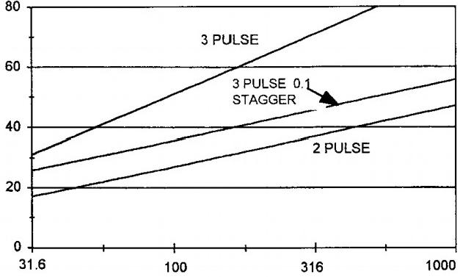
IMPROVEMENT FACTOR(dB)
PRF/CLUTTER BANDWIDTH
100 1000
Figure 5.16 Cancelers improvement factor for stagger and nonstagger.

stagger and a three-pulse canceler with a0.1stagger.It can be seen that staggering significantly reduces the achieved clutter cancellation.

5.4.8 Implementation Errors Effect on Improvement Factor
There are several unavoidable implementation errors that limit the ability ofMTI delay line cancelers to null clutter.Because cancellation involves the subtraction of large voltages,small errors cause large changes in the residue value.One error source is pulse-to-pulse transmitterinstability,or drift.That is,any pulse-to-pulse transmitter amplitude or phase change degrades the cancellation of a stationary target.Possible causes of transmitter instability are power supply ripple due to imperfect conversion ofACvoltage to DCvoltage,varyingtransmitter loadingby the waveguide termination due to antenna scanning,and temperature drifts,for example.Other error sources include local oscillator phase and frequency drifts, PRI and canceler delay line mismatch,nonlinear amplifiers,A/D quantization and saturation effect,and channel-to-channel gain mismatches.
5.4.8.1 Transmitter Phase and Amplitude Drift Effect
The phasor diagram of Figure 5.17 represents consecutive pulse returns from a stationary target.The indicated pulse-to-pulse phase and amplitude change are due to transmitter drift.Denote the amplitudes of the two pulses as E₁and E₂, respectively.First,consider only phase drift so that the two pulses have the same magnitude.In the figure,both are radii of a circle and the connecting arc has length φE,where E denotes the common magnitude.The magnitude of the output of a two-pulse canceler equals
leour!=|E₁-E₂I/√2

and because the connecting chord is approximately equal to the connecting arc, the output magnitude is approximately equal to φE and so the improvement

Clutter return-pulse 1
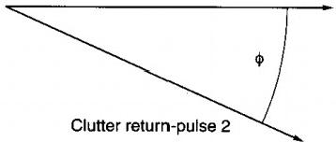
Figure 5.17 Phase-amplitude errors analysis diagram.

factor is approximately
I=2(|E₂I/IE₁-E₂|)²=2φ²
(5.31)
IaB=20 log(I)=3+20
log(φ)

As examples,when the pulse-to-pulse phase drift equals 0.01 radians(0.06 deg- rees),the improvement factor is limited to 53dB;when the pulse-to-pulse phase drift equals 0.1 radians(0.6 degrees),the improvement factor is limited to 23dB.
Similarly,when the two consecutive pulses differ in amplitude,the equiv- alent of(5.31)is
I=2(|E₂I/IE₁-E₂I)²=2(E/8E)²

The transmitter amplitude drift specification is usually determined via

dBE=20 log(IIE₂I/E₁I)=20log[1+(8E/E)]
(δE/E)≈0.115dBE

where d Be is the pulse-to-pulse amplitude drift expressed in decibels.Then
IaB=3-20 log(0.115dBE) (5.31a)

As examples,when the pulse-to-pulse amplitude drift equals 0.10dB,the im- provement factor is limited to 51.8 dB;when the pulse-to-pulse amplitude drift equals 0.05 dB,the improvement factor is limited to 57.8dB.Plots of(5.31)and (5.31a)are shown in Figure 5.18.Note that the phase and amplitude errors are cumulative.Thus,as an example,if the equipment design specification is for an improvement factor of 30 dB,a design budget of 33dB for each effect could be established.This translates to equipment design requirements of pulse-to-pulse phase drifts ofless than 0.055 radians(2.6 degrees)and pulse-to-pulse amplitude drifts of less than 0.385 dB.
5.4.8.2 Transmitter-Local Oscillator Frequency Drift
Phase and amplitude drifts are a pulse-to-pulse effect.In addition,transmit- ters and oscillators can drift in frequency between pulses.It is shown that the improvement factor as limited by frequency drift equals
I=2[2πkT(T+2TR)]-²

where T is the PRI,kT is the pulse-to-pulse frequency change,and TR is the

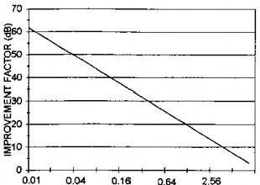
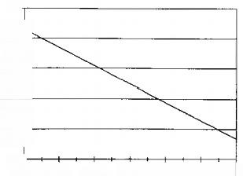
AMPLTUDE ERROR-dB
70-
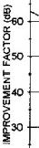
20+
0.001 0.002 0.004 0.0080.016 0.032 0.064
PHASE ERROR-RADIANS
Figure 5.18 Amplitude and phase error limitations on delay line cancelers.

range time to the target.For a typical short-term instability of kT=0.1 Hz (10-¹0 short-term instability at a carrier frequency of 1 GHz)and a PRF of 300 Hz,the achievable improvement factor is limited to 56.7 dB at near range and 47.2 dB at far range.
The effects of transmitter or oscillator frequency drifts are identical.For simplicity of analysis,it is assumed that the transmitter is perfect and only the local oscillator drifts in frequency.
Assume the complex envelope of the transmitter voltage for pulses 1 and
2 are

V1=p(t)exp(j2π fot)
V2=p(t-T)exp(j2π fot)

The reflected pulses for a stationary target are

ei=Vp(t—TR)exp[j2π e2=Vp(t-T-R)exp[j2π
fo(t 一TR)]
fo(t-TR)]
where V represents the amplitude of the return.Assume the oscillator has a linear frequency drift so that its complex envelope is given by an expression identical to that of an LFM waveform,specifically exp(j2π fot+kt²).Then demodulating the return pulses with the local oscillator gives

e1=V'p(t-R)exp(-j2π kt²)
e₂=V'p(t-T-R)exp(-j2πkt²)
V′=Vexp(-j2π foR)

Delaying pulse 1 and subtracting from pulse 2 then gives
eout =V'p(t-T-R){exp(-j2π kt²)-exp[-j2πk(t-T)²1}/√2
and for small errors this is approximately
eou =V′p(t-T-R)[exp(-j2πkt²)(j2πkT)(T-2t)]/√2
so the envelope at the time of the target return,t=T+TR,is leoutl=V2πkT(T+2π)/√2
and the improvement factor is
I=2[2πkT(T+2π)]-²

At R=0 and at TR equal to the maximum range-time of T,the improvement factor equals
I(0)=2[2πkT(T)]-² I(T)=2[2πkT(3T)]-²

so the improvement factor decreases by a factor of three(9.5 dB)from the minimum to maximum ranges.
A typical short-term oscillator instability is that kT=0.1 Hz(10-10 short-term stability at 1 GHz)and for a 300 PRF,I(0)=56.7 dB and I(T)= 47.2 dB.
5.4.8.3 Nonlinearity
The primary sources of nonlinearity are amplifiers and A/D converters.The amplifier nonlinearity can occur in RF,IF,or video amplifiers.Some early radar purposely used nonlinear amplifiers with a logarithmic characteristic in order to achieve a larger dynamic range or limiting amplifers to attain a CFAR- like characteristic.Eventually,it was realized that nonlinearity degraded the cancellation achieved by Doppler cancelers,and currently the goal of amplifier design is to achieve largedynamic range linear amplifiers.Thus,only inadvertent, soft-saturation amplifiers are considered in this section.
The other source of nonlinearity is A/D converters.The nonlinearity of this device has two components.One component occurs because A/Ds are implemented with a fixed number of bits,so they will hard limit when the input exceeds the A/D dynamic range.The second component is conversion noise. That is,the digital output can only be one of a finite set of states and therefore

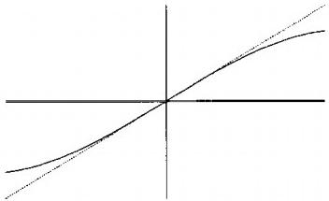
INPUT VOLTAGE
OUTPUT VOLTAGE
Figure 5.19 Nonlinear amplifier input-output characteristic.

the digital output voltage differs from the infinite state input analog voltage in a noise-like manner.
5.4.8.4 Nonlinear Amplifiers
A typical nonlinear input-output characteristic due to the combined mixer and flter before the A/D converter in one of the two digital channels of Figure 1.20 is shown by the curves of Figure 5.19.These components are analyzed because the loss obtained is indicative of the loss for other types of components,such as IF amplifiers;and this analysis,though complicated,is much simpler.The dashed line depicts the ideal,linear input-output characteristic.The solid curve depicts the actual nonlinear input-output characteristic.The compression ratio is defined as the ratio of the actual ourput power to the ideal output power for a sinusoidal input and its value depends upon both the input power level and the degree of nonlinearity.
The nonlinearity causes a decrease of the attainable clutter attenuation of a delay line canceler.The losses are computed using equations derived in the next section for the assumption that the clutter is random and its probability density function is Gaussian.The losses are computed for the two cases that the clutter attenuation of the two-pulse linear canceler is 30 dBor 40 dB.This is equivalent to specifying the value of the autocorrelation function as 0.999 or 0.9999 for a delay of one PRI so that this curve is for any clutter spectral shape or bandwidth.The corresponding autocorrelation value for a twice PRI delay,tequired to evaluate the three-pulse canceler performance,depends upon the clutter spectrum.Losses have been computed for a Gaussian shape and a rectangular shape clutter spectrum.The latter is the approximate spectrum for weather clutter due to wind shear as a function of altitude.When the two-pulse linear canceler clutter attenuation equals 30 dB,the clutter attenuation of the

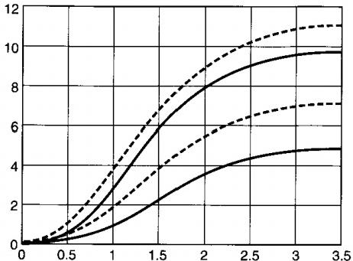
Clutter attenuation loss(dB)
Compression(dB)
Figure 5.20 Clutter attenuation loss due to amplifier nonlinearity.

linear three-pulse canceler and a Gaussian spectrum evaluates to 57 dB;for the rectangular spectrum it evaluates to 59.2 dB.
Figure 5.20 graphs the clutter attenuation decrease as a function of the compression ratio for two-and three-pulse cancelers for two clutter spectra and two different spectra widths.There are six curves on the figure but two cannot be seen because they superimpose on other curves.
The lowest loss curve is for the two-pulse canceler for either spectrum.The curve is for both the 30-and 40-dB linear canceler condition because the curves superimpose.It can be seen that relatively small amounts of nonlinearity cause significant cancellation degradation.
The other three curves are for the three-pulse canceler.The solid curve is for the Gaussian clutter spectrum and both 30-and40-dB clutter attenuation for the linear implementation because the curves superimpose.The dashed curves are for the rectangular spectrum.The larger loss is for the 30-dB linear canceler. It can be seen that there are cases where the loss is sensitive to the spectrum,both spectral shape and bandwidth,and cases where it is not.Thus,to obtain accurate loss values,it is necessary to evaluate the equations ofthe next section for the exact case of interest.In addition,the particular nonlinearity that is analyzed is chosen primarily for analytic convenience so as to demonstrate the trend of the results.
5.4.8.5 Amplifier Nonlinearity Analysis
The amplifier's input-output voltage characteristic is approximated as
(5.32)

andα=0 for a linear amplifier.The analysis evaluates the clutter attenuation for the two-and three-pulse canceler via(5.17)and (5.20).It is necessary to compute the values of the autocorrelation functions R(O),R(T),and R(2T). Denote the I or Qchannel input clutter as a real-valued zero-mean Gaussian random variable x with variance P.R(0)is given by
R(O)=E[x-αx³]²=E(x²-2αx⁵+α²x⁶)

where E()denotes the statistical expectation operatot.As shown in standard
texts,
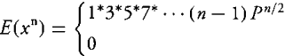
n even integer n odd integer
(5.33)
In particular,

E(x²)=P E(x⁵)=3P² E(x⁶)=15P³
(5.34)

SO

R(0)=P(1-6α P+15α²P²)
(5.35)

Denote two successive random voltages as xj and x₂.R(τ)is defined as
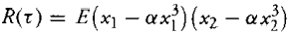
and by symmetry this reduces to

R(τ)=E(x₁x2-2αx1x³+α²x³×2) (5.36)
The correlation coefficient of x₁and x₂is p,so

E(x₁x2)=pP

The evaluation of the remaining terms of(5.36)can be done by decomposing x1 and x₂into a sum of the independent,zero-mean,variance P,Gaussian random
variables y1 and y2.Thus,
x1=y1 x2=py+y₂√(1-p²)

Note that the decomposition construction yields,as required,that xi and x₂ are both zero-mean Gaussian variates with variance P and their correlation coeffcient equals p.Then it is straightforward to show that
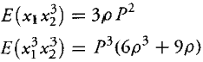

so
R(t)=pP[1-6αP+α²P²(6p²+9)] (5.37)

R(t)can be computed as R(T)or R(2T)using the appropriate value of the correlation coefficient in(5.37).The clutter attenuation is computed using (5.17)and(5.21),giving the graphs of Figure 5.20.

5.4.9 A/D Converters
An A/D converter outputs a digital word that is an approximation of the input analog voltage.One advantage of the digital implementation is that further processing can usually be performed with much greater accuracy than can be attained by practical analog implementations.An example is very low range sidelobe levels.However,the attained performance is decreased as compared to the nonimplementable theoretical optimum processor.There are two separate aspects of the performance degradation.One is due to the discrete time sampling of a time-continuous waveform.Another is due to the approximation of an analog waveform by a number of discrete voltage levels.
5.4.9.1 Straddling Loss
The A/D converters sample the I and Qchannels of the input waveform at the sampling frequency,f.For an LFM waveform of duration t,approximately ft samples are obtained during the duration of a reflected waveform.Pulse compression and Doppler filtering is then performed via the digital processor.
As will be discussed in greater detail,the output of the digital processor is approximately equal to that obtained by sampling the output of an analog- implemented processor if the sampling frequency is at least equal to the LFM bandwith(the Nyquist rate).As depicted by the left-hand sketch of Figure 5.21, in general,the timing of these samples is such that no sample occurs at the precise instant ofthe peak of the pulse compression waveform.Missing the peak decreases the achieved SNR and therefore decreases the achieved probability of detection.This loss is termed the straddling loss because the samples will tend to straddle the instant of the peak.Since the time difference between the

RELATVE SAMPLING FREQUENCY
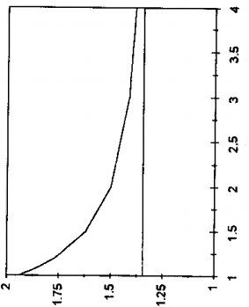
(aP)sSo1 ONnaavyIs

Figure 5.21 Straddling loss for Hamming weighting ofLFM.

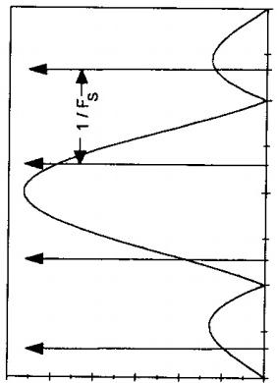

waveform peak and the sample is random,the loss is random and the average loss is computed.The average loss depends upon the range sidelobe suppression weighting that is implemented.The averagelosshas been evaluated for Hamming weighting of a rectangular spectrum and is shown in the right-hand graphs of Figure 5.21.The horizontal axis is the ratio of the A/Dsampling frequency,f,to the two-sided bandwidth.The totalloss,computed relative to an analog-matched flter,has two components.One component is the Hamming weighting loss of 1.35dBshown by the horizontalline.The other component is due to the discrete time sampling.The total loss,the sum of the two components,asymptotically approaches the Hamming weighting loss as the sampling frequency increases. However,the implementation cost ofa digital processor increases approximately linearly with the sampling frequency,so there is a trade-off between loss and implementation cost.
5.4.9.2 Waveform Sampling Analysis
A waveform sampler generates an approximation of the waveform value at a time instant by gating the waveform with a narrow pulse centered at the specific time instant and measuring the energy contained in the gated output.If the pulse is essentially an impulse,the energy is proportional to the waveform's voltage value at the sampling input.The error induced because the sampling pulse is not an impulse is usually of no consequence for common radar bandwidths but a cautionary note is that sometimes it could be significant.
Thus,it is assumed that the waveform sampling is done by a perfect impulse sampler at a constant frequency f.For analytic convenience and without loss of generality,the sampler is assumed to generate complex-valued outputs so that only a single channel need be considered.For a complex-valued input waveform x(t),the nth sample at time instant n/fs =x(n/f).Thus,the
sampled waveform input to the digital processor is
ein(t)=∑x(n/f)8(t-n/fs)
Since ein(t)is the product of x(t)and the infinite impulse train,the spectrum Ein(f)equals the convolution of X(f),the spectrum of x(t),and the spectrum of the infinite impulse train.To develop the spectrum of the infinite impulse train,note that in Section 2.1.2,the impulse function was approximated as the limit of a single unit area pulse as the pulse width approached zero.Similarly,the infinite train ofimpulses can be approximated as a finite train ofunit area pulse as the width of each pulse approaches zero and the number of pulses approaches infinity.The limiting operation shows that the Fourier transform pair is

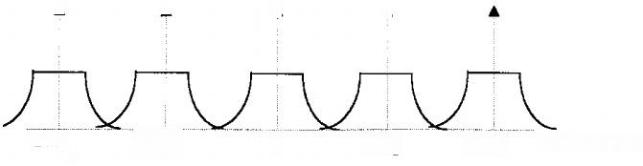
▲

1/Fs 2/Fs
FREQUENCY
-1/Fs
-2/F
▲
▲
▲
S
0
Figure 5.22 Sampled spectrum of LFM waveform.

so the transform is an infinite impulse train in frequency with frequency spacing of fs.
The complex envelope of the transmitted waveform equals a scalar multiple ofs(t)with spectrum S(f).The transfer function for the matched filter is S*(f). The reflected waveform,neglecting thermal noise,equals s(t—to),where to denotes the time delay due to the target range.Therefore,the spectrum of the reflected waveform is S(f)exp(j2π to).The spectrum of the sampled waveform equals
Ein(f)=S(f)exp(j2π to)⊗∑8(f-nf)

where denotes convolution.A sketch of the spectrum,Ein(f)is shown in Figure 5.22.If the spectrum,S(f)is strictly bandlimited,meaning it has no energy outside of a bandwidth B,and if fs is greater than or equal to B,the adjacent spectral portions separated by f do not have any overlap.The spectra of pulsed radar waveforms are not bandlimited because it can be shown that a waveform cannot be both timelimited and bandlimited.Alarge time-bandwidth product LFM waveform is approximately bandlimited,and if the sampling fre- quency is sufficiently large,the sampled waveform can be well approximated as bandlimited.The matched flter for the sampled waveform is
EMF(f)=S(f)⊗∑8(f-nf) and the spectrum of the output is
Eou(f)=|S(f)I²exp(j2πto)⊗∑8(f-nf) The inverse transform gives the filter output as

eour(t)=Rs(t—to)∑ 8(t-n/f)

where Rs(t-to)denotes the analog-matched filter output.Thus,the output equals the sampled analog-matched filter output.

5.4.10 A/D Quantization Effects
The performance will be analyzed for both a thermal noise and aclutter environ- ment.It is shown that in a thermal noise environment,the detection probability is decreased because of the introduction of quantization noise.The amount of degradation decreases as the number of A/D bits(the number of quanta states) increases and increases with the design dynamic range.It is shown that the clutter cancellation degradation using A/D converters is negligible.
A conceptual implementation of an A/D converter is illustrated by the following flow procedure.The A/D converter is a pipeline of several stages,so the input of each stage is the output of the prior stage.For each analog input voltage,the output of each stage is a zero or one so that the converter generates a K-bit digital word.The converter saturates if the magnitude of the analog input exceeds its maximum design level.Denote the maximum design magnitude as Vmax.For an input voltage within the range of±Vmax,the first stage of the converter outputs a one if the input voltage is positive and a zero if the input is negative and passes the absolute magnitude of the input to the next stage. This stage subtracts Vmax/2 from its input.The next bit of the word is one if the subtracter output is positive and zero if the subtracter output is negative. The absolute magnitude of the subtracter is passed to the next stage.This stage subtracts Vmax/4 from the input.It outputs a digital one if the subtracter output is positive and a zero if the subtracter ouput is negative and passes the absolute magnitude of the subtracter output to the next stage.This procedure is repeated for the successive stages.Note that the A/D converter is a precision built analog device and is subject to all the small errors of other analog equipment.
5.4.10.1 Effect of A/D Converters on Target Detection in Noise
An approximation to the input-output characteristic of an A/D converter is shown in Figure 5.23.One reason it is an approximation is that the transitions are shown as precisely uniform with quanta steps of q.Since an A/D converter is actually an analog device,errors cause the transition points to be slightly nonuniformly spaced.Another reason the characteristic is an approximation is that it is shown with an odd number of states.However,the digital word has an even number of states,2K,for a K-bit converter and therefore cannot have the illustrated odd symmetry.However,the unrealistic input-output characteristic is a close approximation to reality,illustrates the characteristic,and considerably

5ut^ q

-q/2
q/2 En

Figure 5.23 A/D input-output characteristic.

simplifes the performance analysis.The input-output equation for the charac- teristic of Figure 5.23 is

-q/2<Ein<q/2 →Eou=0
q/2<Ein<3q/2→Eout=q q/2<Ein<-3q/2→Eout=-q
3q/2<Ein<5q/2→Eout=2q -3q/2<Ein<-5q/2→Eout=-2q
5q/2<Ein<7q/2→Eout=3q -5q/2<Ein<-7q/2→Eout=-3q

The major A/D characteristics are quantization noise and saturation.The quantization noise occurs because the output voltage differs from the input voltage.Thus,

Eout =Ein+δ

and the error δmay be approximated as a zero-mean,random variable with uniform probability density function over the range of(-q/2,q/2)so that its variance equals. .The random error is noise-like,decreases the target SNR, and therefore decreases the probability of detection.That is,the total noise equals the sum of the thermal noise power, and the quantization noise.The total noise power equals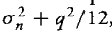 so the SNRA/D as compared to the optimum SNR is

SNRA/D=SNRoPT/{1+[1+1/12(o21q²)-¹]} (5.38)

The loss is decreased when the ratio of on to q is large,which means that the

noise spreads over many quanta.The loss equals 0.35 dB for on/q =1 and
0.23 dB for on/q=1.5.
Saturation occurs because there are 2K states with 2K-¹positive states and 2K-¹negative states.Since the size of each state is q,the saturation voltage level equals q2K-1.The maximum CNR before saturation(the dynamic range)is thus
(5.38a)

Note that this definition is optimistic in the sense that for a random input of relative power level CNRMAX,saturation occurs when the magnitude of the random voltage exceeds one standard deviation.For a Gaussian-distribured ran- dom voltage,the probability ofsaturation for a relative input power of CNRMAX equals 0.32.
As shown in the previous section,saturation (compression)degrades the clutter cancellation.Increased dynamic range is obtained using a many bit con- verter,an expensive implementation,and/or using a large value for q,which implies that the noise spreads over very few quanta.Thus,there is a trade be- tween large dynamic range and small target detection loss.Figure 5.24 shows this trade.The horizontal axis is the ratio of the noise's standard deviation(the square root of the noise power)to the A/D quanta,σn/q.The left-hand vertical axis is the SNR loss computed from(5.38).The right-hand vertical axis is the dynamic range.The solid curve shows the SNR loss.The two dotted curves show the dynamic range for an 8-bit A/D and a 12-bit A/D.

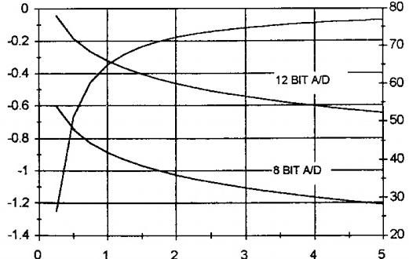
SNR 7OSS)dB)
DYNAMIC RANGE(dB)
SIGMA/Q
Figure 5.24 Trade of SNR loss and dynamic range for A/D converter.

5.4.10.2 Effect of A/D Converters on Clutter Cancellation
Denote the complex envelope voltages ofthe analog clutter inputs to a multipulse canceler as x1,x2,and x₃,for example.The A/D outputs are xi+81,x2+82, andx₃+83,for example,where the nth conversion error is denoted as δn.The A/D canceler output is

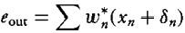
The output power has two components:one due to the clutter andone due to the quantization.Assuming the pulse-to-pulse quantization errors are independent and noting that the sum ofthe magnitude-squared weights equals one,the output quantization power equals the per-pulse quantization power.Thus,denoting the ratio of the per-pulse clutter power to the thermal noise power as CNR,the residue power,including thermal noise,for a two-pulse canceler and the clutter attenuation equals
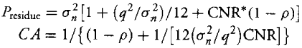
(5.39)

Thus,the clutter attenuation is decreased and the loss depends upon the input CNR and the A/Don/q value.The loss decreases as the on-to-q ratio increases.
Examples of the dependence are graphed in Figure 5.25.The right-hand portion of Figure 5.25 shows the clutter attenuation versus CNR for on-to-q ratios of 1 and 2.It can be seen that at high levels of input CNR,the clutter attenuation is not affected by the quantization noise but is limited by the decorre- lation of the two clutter voltages for the adjacent pulses.At smaller CNR values, the quantization noise causes significant canceler degradation.The ratio of the residue power to the noise power is shown in the left-hand portion of Figure 5.25

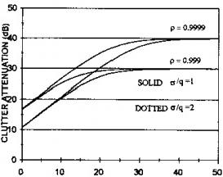
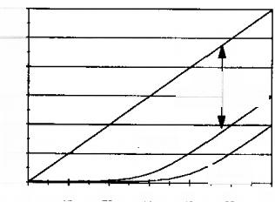
R g E g o 嗡
INPUT CNR(dB)
CLUTTER
—ATTENUATION
p*0.999
10 ·
p-99
0 10 20INPUT30CNR(d 50 60
2
Figure 5.25 Quantization noise effect on two pulse canceler.

198 Radar Signal Processing and Adaptive Systems

foron/q=1.For high levels ofCNR,the residue power is approximately equal to the input CNR reduced by the clutter attenuation.For low levels of CNR, the clutter attenuation is sufficient to reduce the ouput cluter power to a level that is much less than the output thermal noise power.Thus,A/Dquantization has little effect on detection of targets in clutter.The conclusion is that the de- sign choice of the on-to-q ratio is primarily determined by target detection in a thermal noise interference environment.Another conclusion from the left-hand portion of Figure 5.25 is that the residue power deviates considerably from the thermal noise power level so that a CFAR circuit is mandatory when operating in a clutter environment.

5.4.11 Special Doppler Processing for Airborne Radar
To state the obvious,a major difference between a ground-based radar and an airborne radar is that the airborne radar is on a moving platform.This causes a major problem when applying the previously considered delay line cancelers. Specifically,these cancelers are designed to cancel cluter whose mean Doppler frequency equals zero.However,due to the platform motion,the clutte's mean Doppler frequency is not zero and in addition changes as the platform speed changes.Figure 5.26 depicts the geometry for an airborne radar.As an example, assume the radar carrier frequency equals 1000 MHz and the aircraft's velocity, V,equals 600 m/s(approximately Mach 2).The Doppler frequency,foLos, along the line of sight(LOS),is
foLos =2Vfo cos(α)/c (5.40)
For a depression angle of 20 degrees,this evaluates to 3758 Hz.Thus,the delay canceler null at zero is unsatisfactory and a method of compensating for the aircraft velocity is mandatory.

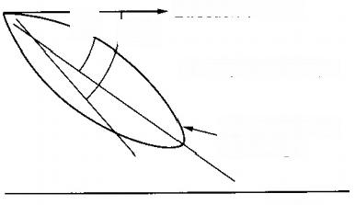
Ground
Direction of travel
α a+θ
α=depression angle

Antenna pattern line of sight

Figure 5.26 Airborne radar clutter geometry.

Target Detection in Clutter 199

In addition,the Doppler frequency of stationary clutter varies across the antenna beamwidth.For a 20-m-diameter antenna,the two-sided beamwidth approximately equals 0.86 degrees,so the clutter spread equals±3758 sin(0.53°) or 28.2Hz.For this spread,even if the LOSDoppler were perfectly compensated, the clutter Doppler spread would severely limit the achievable cancellation.Fora three-pulse canceler and a PRF of 300 Hz,from(5.22),the improvement factor evaluates to 12.2 dB.If the PRF is increased to 1000 Hz,accepting the resultant range ambiguities,the improvement factor is only 33.1 dB.

5.4.12 Airborne Radar Doppler Compensation Techniques
The technique that compensates for the LOS Doppler is TACCAR(time- averaged clutter coherent radar).Its operational concept is to measure the nom- inal Doppler along the LOS for a nominal transmission frequency of fo but actually transmit the carrier frequency fo-foLos.Thus,the received Doppler- shifted frequency equals fo and the mean clutter frequency is at the null of the delay line canceler.A conceptual block diagram of the technique is shown in Figure 5.27.The frequency of the reflected waveform is measured by the frequency discriminator.This frequency is noise-like due to the changing char- acteristics of the clutter along the aircraft's trajectory and across the beamwidch. The noisy frequency measurement is averaged by the cascaded low-pass filter.The resultant voltage is used to modify the output frequency of a voltage-controlled oscillator.Mixing the oscillator output with the RF oscillator produces the final
transmTiefqcuye. that compensates for the antenna beamwidth and vehicle
motion-induced clutter spread is a displaced phase center antenna(DPCA). The spread is caused by the antenna motion between consecutive pulses.The

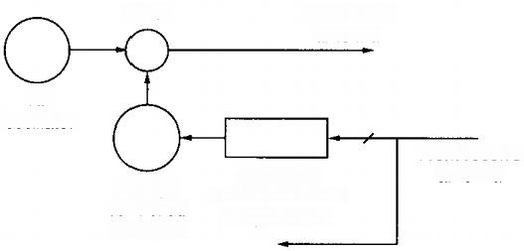
Mixer To transmit
antenna

RF
oscillator

Voltage controlled oscillator
From receive antenna
Frequency
discriminator and
low pass filter
To signal processor
Figure 5.27 Conceptual block diagram of TACCAR.

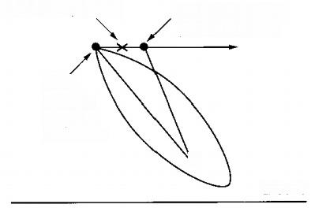
Mean A/C position A/C position for
pulse 2 transmit

A/C
position
for pulse
1 transmit
Ground
Phase monopulse
Figure 5.28 DPCA geometry concept.

geometry of this motion is depicted in the left portion of Figure 5.28.The com- pensation scheme is based on modifying the clutter returns,so they are equivalent to what would be received if the transmitting antenna was at the mean aircraft position for both pulse transmissions.Its method of operation depends upon the fact that the clutter's one-sided Doppler spread depends only upon the vehi- cle forward speed,the antenna depression angle,and the antenna diameter.The spread does not depend directly upon the carrier frequency.Therefore,the spread depends upon system parameters that are either known or can be measured with high precision.
The compensation is performed using the two outputs of a phase mono- pulse antenna as depicted in the right portion of Figure 5.28.For an isolated point target at an angle θ from the LOS,the voltages received at the two feeds of the monopulse antenna are
e1=A exp(jφ/2) e2=A exp(-jφ/2) (5.41)

The differential phase shift is due to the distance D between the antenna feeds and the angleθ from the LOS.Thus,
φ=(2π/λ)D sin(θ)

The sum and difference signals are

∑=e1+e2=A exp(jφ/2)+A exp(-jφ/2)=2A cos[πD sin(θ)/λ] △=e₁-e2=A exp(jφ/2)-A exp(-jφ/2)=j2A sin[π D sin(θ)/λ]
(5.42)

Note that the sum signal is always real and the delta signal is always imaginary. Also,the phase of the △ signal is+π/2 when θ is positive and is—π/2 when θ is negative.Thus,the relative phase of the sum and delta signal provides information as to the relative angle of a reflector.
Clutter at an angle θ from the LOS has a radial velocity,Vc,relative to that of the LOS of

Vc=V[cos(α)-cos(α+θ)]=V{cos(α)-[cos(α)cos(θ)-sin(α)sin(θ)]}

and for θ small this is approximately

Vc≈V sin(α)sin(θ)

so the Doppler frequency is approximately

fo=2fo[sin(θ)V sin(α)]/c

The relative phase of the sum signal for pulses 1 and 2 due to the Doppler frequency,denoted as 2η,is

2η=2πfbT=5π foTTθV sin(α)]/c=5πT[sin(θ)V sin(α)]/λ(5.43)

and this phase difference is also positive or negative depending upon the relative angle of the clutter with respect to the LOS.The compensation scheme amplifies the pulse 1 delta signal by the real value g and adds it to the pulse 1 sum signal. The pulse 2 delta signal is amplified by the same factor g and is subtracted from the pulse 2 sum signal.This action is depicted in Figure 5.29.Note that complete cancellation occurs if the gain g is properly chosen.From the diagram,

g delta
Sum2

2η

Sum 1
-g delta

Figure 5.29 DPCA compensation.

the requirement is that
tan(η)=g△/∑

Thus,the required gain value for perfect cancellation is
g(θ)=[∑(θ)/△(θ)]tan(nθ)
and combining with (5.42)and (5.43)gives

g(θ)={cos[π D sin(θ)/λ]/sin[π D sin(θ)/λ]}tan{2π T[sin(θ)V sin(α)]/λ} Therefore,if
D=2VT sin(α) (5.44)

g(θ)equals unity for all values of θ and so matching the antenna design,with respect to diameter and depression angle,to the vehicle velocity ensures total compensation and the clutter spectrum is positioned at the null of the delay line canceler.

5.5 Doppler Filter Banks
As discussed in Section 5.4.4,the delay line canceler is not an optimum pro- cessor and for an N-pulse transmission,the output SNR is usually much less than Ntimes the SNR ofa single pulse.The SNR gain can be increased to ap- proximately Nforall Doppler frequencies using a Doppler flter bank processor. The conceptual block diagram of Figure 5.30 shows a single filter of a Doppler flter bank.The phases of the gain set g₁,…,gn are used to steer the filter's main response region to a particular Doppler,and the magnitudes of the gain set are used to control the sidelobe response.For a Doppler frequency of fo,the

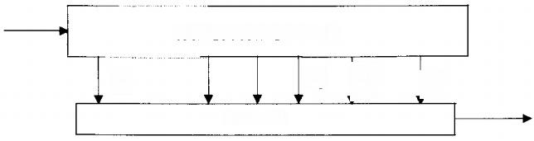
TAP SPACING=PRI

93
9N
91
92
SUMMER
Figure 5.30 Conceptual block diagram of a Doppler filter.

filter input is the cisoid exp(一j2π fot).The output of the nth delay line tap is exp{-j2π fo[t-(N-n)T]}.Thus,the magnitude of the complex envelope of the filter’s output voltage for the nth filter of the bank is
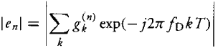
(5.45)

where 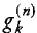 is the weight at the kth tap of the delay line for the nth filter and T denotes the periodic waveform's PRI.Each weight is given as the product of its magnitude and phase as
gk”)=|8k”|exp(j2π fskT) (5.46)

and fs denotes the steered center frequency of the filter.Combining(5.45)and (5.46),the magnitude of the output for the nth flter is
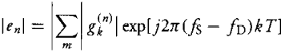
(5.47)

The filter attains its maximum output value when fo=fs and this is denoted as the filter is steeredto fo.Typically the Nvalues of fs are0,1/NT,2/NT,..., n/NT,...,(N-1)/T.
The Doppler response ofa filter steered to zero Doppler frequency is shown in Figure 5.31.It can be seen that the response is periodic at the pulse repetition frequency and that large response only occurs over a Doppler frequency range of approximately 1/NT.It is necessary to use a bank of flters,all tuned to different Doppler frequencies,to cover the total Doppler range.A block diagram of a flter bank configured with Nfilters is shown in Figure 5.32.Each of the parallel filters is cascaded with a CFAR circuit.A different CFAR circuit is required for each filter since the residue clutter power will be different in each flter.The outputs of the CFAR circuits are target present or absent decisions and are passed to the data processor along with angle of location measurements.
A specific example of thefilter responses for an 8-pulse processor are shown in Figure 5.33 for filters implemented with equal magnitude weights.The three flters are steered to Doppler frequencies of 0,1/8T,and 2/8T.The crossovers of adjacent flters are at relative gains of 0.637 or-3.92 dB.A method of decreasing this loss is the expensive option of using more than Nfilters.For 2N flters the crossover loss is decreased to-0.85 dB.However,the probability of detecting SNR loss is less than the crossover loss because the crossover loss does not factor in that the target can be detected in either of the two adjacent filters.

204 Radar Signal Processing and Adaptive Systems Target Detection in Clutter 205

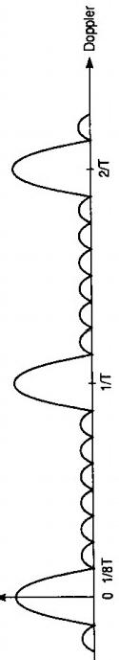
igure 5.31 Single filte Doppler response.

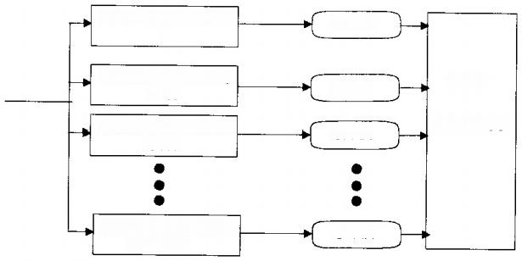
FILTER TUNED TO 0

FILTER TUNED TO 1/NT
FILTER TUNED TO 2/NT

FILTER TUNED TO (N-1)/NT
DATA

PROCESS
CFAR

CFAR
CFAR
CFAR
Figure 5.32 Conceptual block diagram of Doppler filter bank.

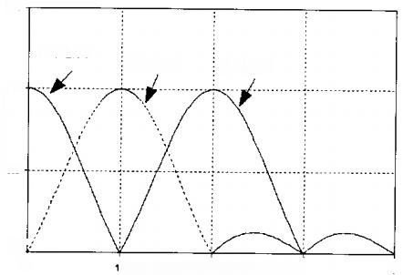
VOLTAGE GAIN
1.5

FILTER 1
FILTER 3
1

0.5,

0 4
NORMALEED DoPPLER FREaUENc³
FILTER 2
Figure 5.33 Responses of multiple Doppler filters.

As an example,for a nonfuctuating target whose Doppler frequency is at the peak of a filter response and has an output SNR of 13 dB,the probability of detection equals 0.87 at a false alarm probability of 1.×10-6.At the crossover Doppler frequency,the output SNR is reduced to 9.08dB for each filter,so the probability of detection for either filter equals 0.13.It is shown in Section 5.1.1 that the probability of detection is statistically independent of the two filters.
Thus,the probability of detection is the probability of detecting in either flter and this equals
B=1-(1-0.13)²=0.24

This probability ofdetection corresponds to a loss of3dB rather than the cross- over loss of 3.92 dB.At other Doppler frequencies,using (4.1),the detection

206 Radar Signal Processing and Adaptive Systems

probability equals²
PD=1-[1-Q(g₁Ap/o,T/o)][1-Q(g2Ap/o,T/σ)]
81=sin(πfDT)/(πfDT) g2=sin[π(1-foT]/[π(1-foT)]
(5.48)

where g₁andg2 are the gains for the Doppler frequency fo in adjacent filters.
A more realistic assessment of the loss is obtained by recognizing that the SNR loss depends upon the target's Doppler frequency.As previously discussed, for the usual search radar PRF the target Doppler is highly ambiguous and often can be regarded as a uniformly distributed random variable.Using this assumption,and integrating(5.48),the SNR loss for an N-pulse processor and N filters in the Doppler bank is approximately 1.15dB.
5.5.1 Statistical Independence of Detection
Because the only cause of randomness for a nonfluctuating target is the thermal noise,the detection events in different filters are independent if the output thermal noises in the filters are independent.Extrapolating(5.45)the output thermal noise for the nth flter equals
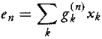
where xkdenotes the thermal noise at the kth tap.If the waveform is sampled with a minimum time separation equal to the inverse of the PRF and the PRF is very much less than the radar's bandwidth,all noise samples are statistically independent.Thus,
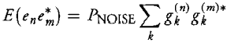
and for equal magnitude weights and steering frequencies of n/Tand m/T,from (5.46),
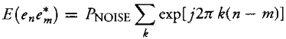
This geometric series sums to zero unless n=m,so the noise is statistically independent in the filters.

207

